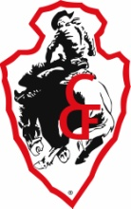
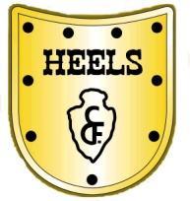

HEELS Shirt Information

The HEELS and CFD Emblems are both trademarks of Cheyenne Frontier Days. It is recommended that all stitching be done through Cheyenne Stitch at 1401 E Lincolnway, Cheyenne, WY 82001, phone (307) 634-0858.

Examples of the White, Blue/Royal Blue, and Tan Shirts:
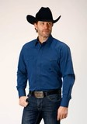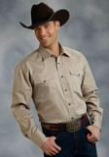

Links from Roper:
White
https://eroper.com/collections/mens-tops/products/0300102651025wh

Blue/Royal Blue
https://eroper.com/collections/mens-tops/products/0300102650185bu

Tan
https://eroper.com/collections/mens-tops/products/0300107651126br

Shirts do not have to be Roper shirts, but at least close to these colors from any western apparel company.

